
Black Friday Creative Was Won In October
2026-09-13 · Mindset & High Performance · STATIC
Recommended: STATIC, not carousel. The idea is one decoded truth, not a sequence: the deadline logic compresses into a single punchline once the number lands. Hook trigger: CONTRARIAN (attacks the common practice of scrambling for creative in November). Open loop subhead: EN "The number that explains why November is already too late. →" | ES "El numero que explica por que noviembre ya llega tarde. →" | PT "O numero que explica por que novembro ja chega atrasado. →". Note on image sourcing: this session has no interactive browser, so every candidate below was verified by downloading the direct file and inspecting pixel dimensions and content directly, not by a live Chrome view; one strong, fully verified hero photo was preferred over forcing six or seven backgrounds of uneven quality onto a carousel.

The Anchor
Subject: Luke Austin, VP of Ecommerce Strategy at Common Thread Collective
Real fact: In Common Thread Collective's September 2026 Q4 guidance, Luke Austin said creative volume for Black Friday and Cyber Monday comes from the number of production sources feeding an account, not from one strategist inventing angles, and that the play is to identify the 20 to 30 creators whose content actually sells, since building that roster takes weeks and has to be in place before the season starts, not during it.
Time peg: news, week of September 8, 2026
Source 1: https://stackinfluence.com/blog/september-2026-ecommerce-news-and-updates-for-sellers
Source 2: https://www.youtube.com/watch?v=cCI7YtmcsUM
Source 3: https://commonthreadco.com/blogs/ecommerce-playbook/best-and-worst-creative-demand-scores

The Big Idea
Black Friday's creative output is decided by how many production sources a brand has lined up weeks in advance, not by how hard one strategist brainstorms in the final stretch.

Audience Takeaway
Treat creator sourcing as a hard October deadline, not a November task. A founder who is still 'figuring out creative' once November starts is not behind by a few days; they are restarting a process that needed weeks to run properly, which means the discipline that wins Black Friday was already spent before the season began.

Headline (the only text on the hero image)
EN: Black Friday creative was won in *October*.
ES: La creatividad de Black Friday se ganó en *octubre*.
PT: A criatividade da Black Friday foi ganha em *outubro*.
Eyebrow: Creator Strategy | Estrategia de Creadores | Estratégia de Criadores
Headline color: #FF3B3B shock red (default magenta swapped for urgency; matches the deadline pressure in the claim) (off-brand allowed; chosen to stop the scroll)

Caption (EN)
Luke Austin runs ecommerce strategy at Common Thread Collective, and he has a blunt read on Black Friday creative. Most brands still treat it like a scramble: one strategist, one big push, sometime in November.
Austin says that model is backwards. In his framework, creative volume for the biggest week of the year comes from the number of production sources feeding an account, not from how hard one person brainstorms, and his own number is specific: twenty to thirty creators whose content actually sells.
Building that roster takes weeks, not days. Finding the right creators, testing their content, and learning which ones convert is its own process, and that process has to close out before the season starts, not during it.
So the brand still figuring out creative in November is not behind schedule. It is running a process that was supposed to finish in October.
Save this. Send it to whoever owns your Q4 creative calendar.
#RarityAgency #BlackFriday #Ecommerce

Caption (ES)
Luke Austin dirige la estrategia de ecommerce en Common Thread Collective, y tiene una lectura muy directa sobre el creativo de Black Friday. La mayoria de las marcas todavia lo tratan como una carrera contra el reloj: un estratega, un empujon grande, en algun momento de noviembre.
Austin dice que ese modelo esta al reves. En su marco, el volumen creativo para la semana mas grande del ano depende de cuantas fuentes de produccion alimentan la cuenta, no de cuanto se esfuerce una sola persona pensando ideas, y su numero es concreto: entre veinte y treinta creadores cuyo contenido realmente vende.
Armar ese equipo toma semanas, no dias. Encontrar a los creadores correctos, probar su contenido y entender cuales convierten es un proceso propio, y ese proceso tiene que cerrarse antes de que arranque la temporada, no durante ella.
Asi que la marca que en noviembre todavia esta resolviendo el creativo no va atrasada. Esta corriendo un proceso que debia haber terminado en octubre.
Guarda esto. Envialo a quien maneja tu calendario creativo de Q4.
#RarityAgency #BlackFriday #Ecommerce

Caption (PT)
Luke Austin lidera a estrategia de ecommerce na Common Thread Collective, e tem uma leitura bem direta sobre o criativo de Black Friday. A maioria das marcas ainda trata isso como uma correria: um estrategista, um empurrao grande, em algum momento de novembro.
Austin diz que esse modelo esta invertido. No raciocinio dele, o volume criativo para a semana mais importante do ano depende de quantas fontes de producao alimentam a conta, nao do quanto uma pessoa sozinha se esforca pensando em ideias, e o numero dele e especifico: entre vinte e trinta criadores cujo conteudo realmente vende.
Montar esse time leva semanas, nao dias. Encontrar os criadores certos, testar o conteudo deles e entender quais convertem e um processo proprio, e esse processo precisa fechar antes de a temporada comecar, nao durante ela.
Entao a marca que em novembro ainda esta resolvendo o criativo nao esta atrasada. Ela esta rodando um processo que deveria ter terminado em outubro.
Salva isso. Manda pra quem cuida do calendario criativo do seu Q4.
#RarityAgency #BlackFriday #Ecommerce

Images (sourced from the web)
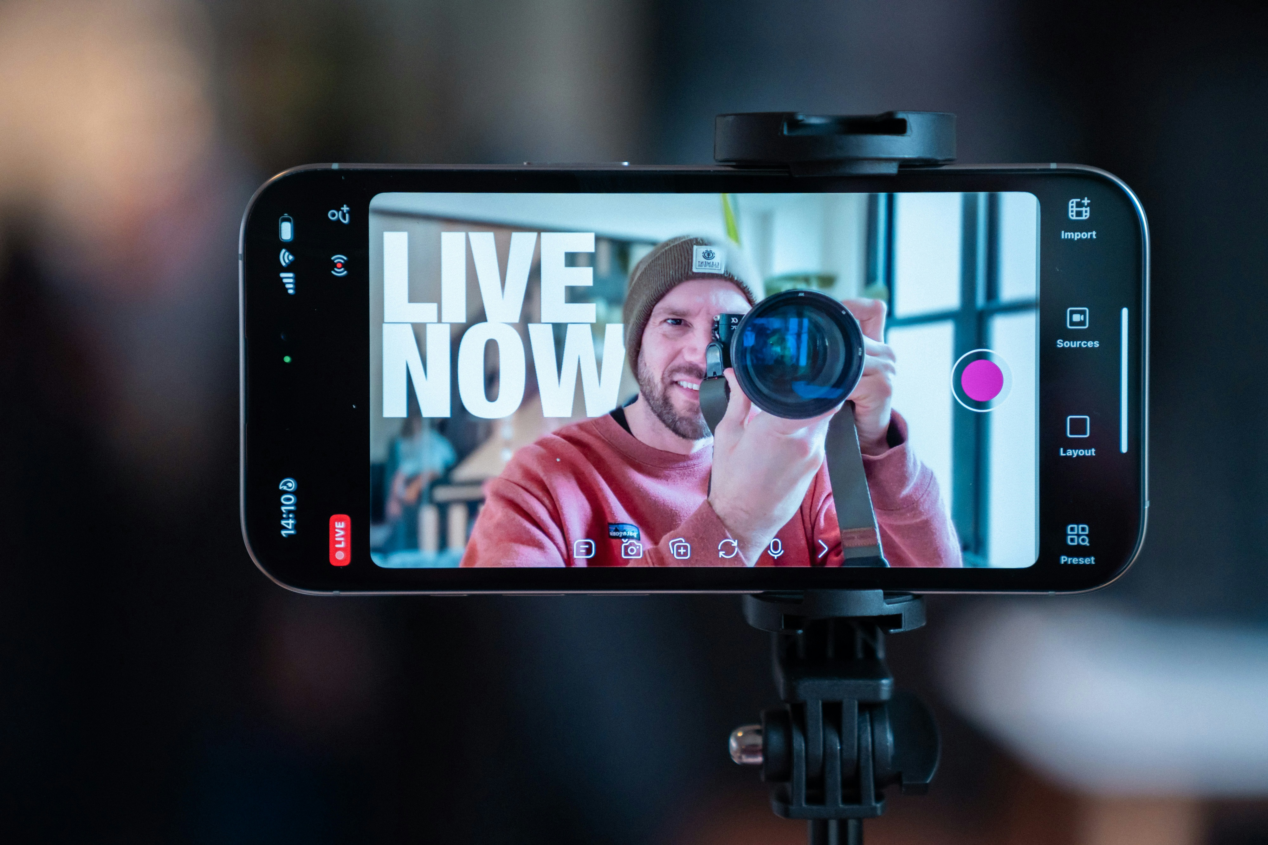
Hero: a smartphone on a tripod mid livestream, LIVE badge glowing, a creator's face seen through the camera lens he is holding up, dark blurred negative space above and below: https://images.unsplash.com/photo-1764162051296-63c5cddf6ba6
Source: https://unsplash.com/photos/man-filming-himself-with-a-smartphone-on-a-tripod-5MRJkV_la-w Author: Detail .co (via Unsplash) License: Unsplash License (free to use, no permission needed; credit appreciated)
Source: IMAGE QA SCORECARD. Gate 0: B1 viewed, the frame was downloaded and visually inspected directly (not chosen from a filename), it shows a black smartphone clamped to a tripod, screen displaying a livestream recording app with a red LIVE badge and LIVE NOW text, framing a man in a beanie holding a camera lens up to his eye, dark blurred bokeh above and below. B2 native file is 4000 by 2667 pixels, short side 2667, well above the 1600px minimum. B3 direct URL verified by downloading the file and confirming it resolves to this exact image, not a search page or thumbnail. B4 not on the banned trope list, it is not a handshake, laptop on a desk, robot arm, or a paid model performing an emotion. B5 used once only, single hero image on a static post, no reuse. B6 license and credit traced from the original Unsplash photo page (unsplash.com), not from a search listing. Scores out of 10. Subject match 8, this is a real, unposed behind the scenes frame from the actual world of creator led content production; the claim itself is a strategic argument with no single named event to photograph, so this is judged as strong metaphor precision rather than a literal newsroom photo. Five unrelated posts test 8, it would suit posts specifically about creator led video, UGC, live commerce or solo content production, and would look out of place on an unrelated post about hiring or finance. Charge 9, the lens points back at the viewer, the LIVE badge glows, the moment reads as genuinely captured rather than staged. Currency 10, current phone hardware, current recording app interface, sharp and contemporary. Legibility 9, clean dark blurred negative space at the top for the eyebrow and headline, and at the bottom for a closing line, strong tonal range to hold a scrim. Set distinction not applicable, this is a static post with a single hero image, not a carousel. Runner up beaten: a second frame from the same free Unsplash series (same photographer, greener and softer lit background) scored lower on charge and legibility, flatter light and less contrast behind the headline zone. A third candidate, a ring light clothing studio shot, was rejected outright on rights: it is Unsplash+ premium content credited to Getty Images, not cleared for use without a paid license. A fourth candidate, a generic laptop screen video call grid, was rejected on subject match and banned trope adjacency (laptop on a desk). A fifth candidate, a small blog photo of several creators filming together, was rejected for unverifiable resolution and an unclear rights trail.

Visual Direction (for the design step)
Hero image: A smartphone clamped to a tripod, mid livestream, a red LIVE badge glowing on screen, framing a creator holding a camera lens up to his eye. Real, current, unposed, high resolution; drawn from the actual world of creator led content production rather than a posed corporate stock shot. Dark blurred negative space above the phone carries the eyebrow and headline; the darker lower third carries the accent line.
Alt image queries: creator filming product review ring light close up high resolution | multiple content creators filming products same studio day DTC brand | solo marketer alone late night deadline stress editorial photo
Color mood: gradient drama, navy to charcoal base with a red accent spike (Mindset & High Performance)
Symbol corner: top-right, transparent white Rarity symbol
Logo (CTA slide): full white logo on dark bg

Rights / Sensitivity
Hero photo is published under the standard Unsplash License (free to use commercially, no permission required, credit appreciated), photographed for the Detail app and traced to its original Unsplash photo page, not a search thumbnail or a pinimg link. The man pictured is an anonymous subject in an editorial stock photo illustrating the broader creator economy; he is not identified as, and must never be captioned or implied to be, Luke Austin himself. No public figure's likeness, tragedy, or protected subject matter is involved. No date appears anywhere on the art.
Next step: run rarity-ig-designer on this brief to build the EN, ES, and PT art with rarity-ig-designer.

